**First Increment Report**

**Caller Buddy (App – App Calling)**

In this Increment,

I implemented the app-app voice calling with user-ids and this feature is working perfectly with Sinch services.

Below are the screenshots of this app in action:

User A Signs in with his ID User B Signs in with his ID

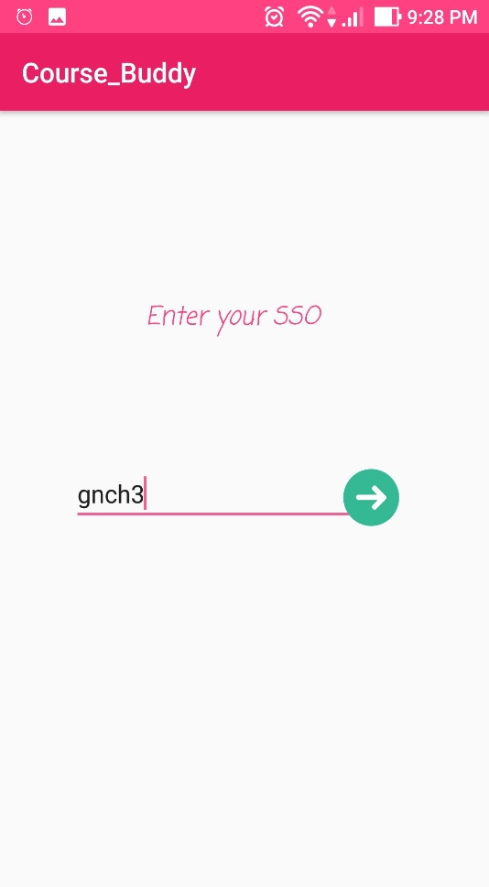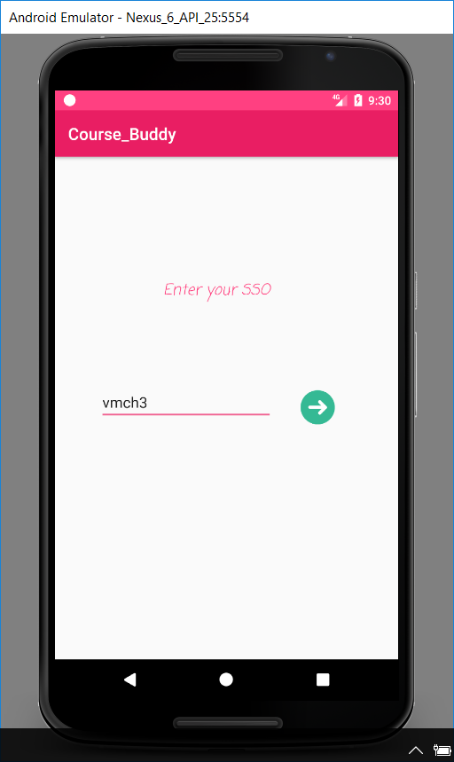



User B enters id of user A and click on Call icon to place a call.

Now the call is placed using Sinch services(VoIP).

**The outgoing and incoming calls looks like the pictures shown below**:

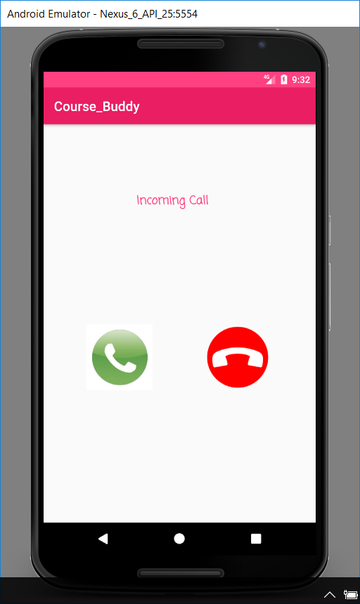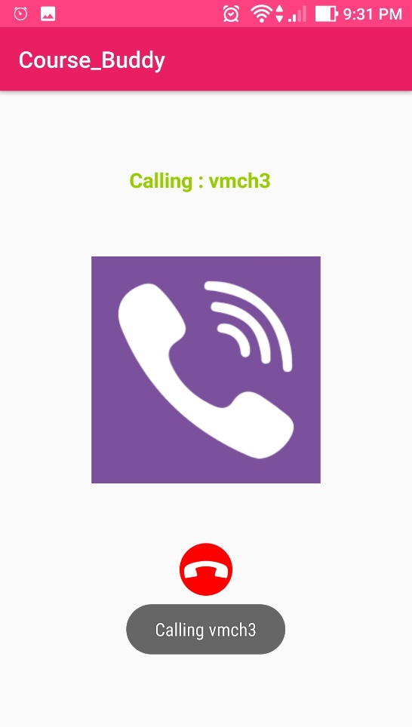

Outgoing Call from User B Incoming call to User A

Next Increment Objective:

* Implement App – App video Calling for users.
* Improve UI Design.